LEVEL 6 — RESEARCH TRACK CAPSTONE
Advanced Statistical Research
Handling uncertainty, hidden structure and causal questions beyond standard regression
Covers: Bayesian modelling / hierarchical models · state-space models / hidden regimes / structural breaks · extreme-value methods / copulas / dependence modelling · causal inference / synthetic controls / instrumental variables / treatment effects

Table of Contents
Right-click and choose “Update Field” (or “Update entire table”) after opening in Word to populate page numbers.
Table of Contents 2
7. Advanced Statistical Research (Level 6) 3
7.1 Learning Position at a Glance 3
7.2 Bayesian Modelling & Hierarchical Models 3
7.3 State-Space Models, Hidden Regimes & Structural Breaks 4
7.4 Extreme-Value Methods, Copulas & Dependence Modelling 5
7.5 Causal Inference, Synthetic Controls, Instrumental Variables & Treatment Effects 6
7.6 Worked Exercise — Model Answer 7
7.7 Common Mistakes — Deeper Look 8
7.8 Advanced Extensions 8
7.9 Professional Applications 8

7. Advanced Statistical Research (Level 6)
Covers: Bayesian modelling/hierarchical models · state-space models/hidden regimes/structural breaks · extreme-value methods/copulas/dependence modelling · causal inference/synthetic controls/instrumental variables/treatment effects

7.1 Learning Position at a Glance
- What it is: Statistical methods for handling uncertainty, hidden structure and causal questions that go beyond standard regression and hypothesis testing.
- Why it matters: Many important quant-research questions (‘does this signal cause returns, or is it confounded?’, ‘how should I update my belief about a signal’s strength given new data?’) require these tools.
- Prerequisites: Statistics (Depth 4+); Time Series (state-space awareness); Probability (Depth 4+).
- Connects to Research: Causal-inference thinking is what distinguishes ‘this feature is correlated with returns’ from ‘this feature has a plausible causal or structural relationship to returns.’
- Connects to Development: Bayesian and state-space models often require custom numerical implementation (e.g. particle filters, MCMC) beyond off-the-shelf libraries.
- Connects to Trading: Regime models built here directly inform the dynamic allocation methods used in Level 5 advanced systematic trading.
- Practical exercise: Use a Bayesian approach to update your belief about a signal’s true Sharpe ratio as new out-of-sample months of data arrive, starting from a skeptical prior.
- Common beginner mistakes:
- Applying causal-inference terminology to a purely correlational finding without a credible identification strategy.
- Using a complex hierarchical or state-space model without checking whether a simpler model already explains the data adequately.
- Advanced extensions: Full measure-theoretic probability for reading advanced academic derivatives-pricing literature, where genuinely necessary.
- Professional applications: Signal confidence-weighting; regime-aware research; academic-grade research publication.

7.2 Bayesian Modelling & Hierarchical Models
Classical (frequentist) hypothesis testing asks: if there were truly no effect, how surprising would this data be? Bayesian inference asks a more directly useful question: given this data, how should my belief about the effect change? The Bayesian approach starts with a prior distribution — an explicit, quantified statement of what is believed before seeing the data — and updates it using Bayes’ theorem to produce a posterior distribution once the data are observed. For a quant researcher, this reframing matters enormously: it naturally handles the fact that most candidate signals are, a priori, unlikely to be real (see §6.6’s discussion of multiple testing), and it produces a full distribution of plausible answers rather than a single point estimate and a pass/fail significance verdict.
A skeptical prior — one centred near zero effect, with most of its probability mass on ‘this signal has little or no true edge’ — is a direct, quantitative way to encode the lesson of §6.6: an as-yet-unproven signal should be assumed weak until enough evidence accumulates to justify believing otherwise. As out-of-sample data arrive, the posterior shifts toward the data, but a truly skeptical prior means a handful of lucky months move the belief only modestly — exactly the caution that a raw backtest Sharpe ratio, taken at face value, does not provide.
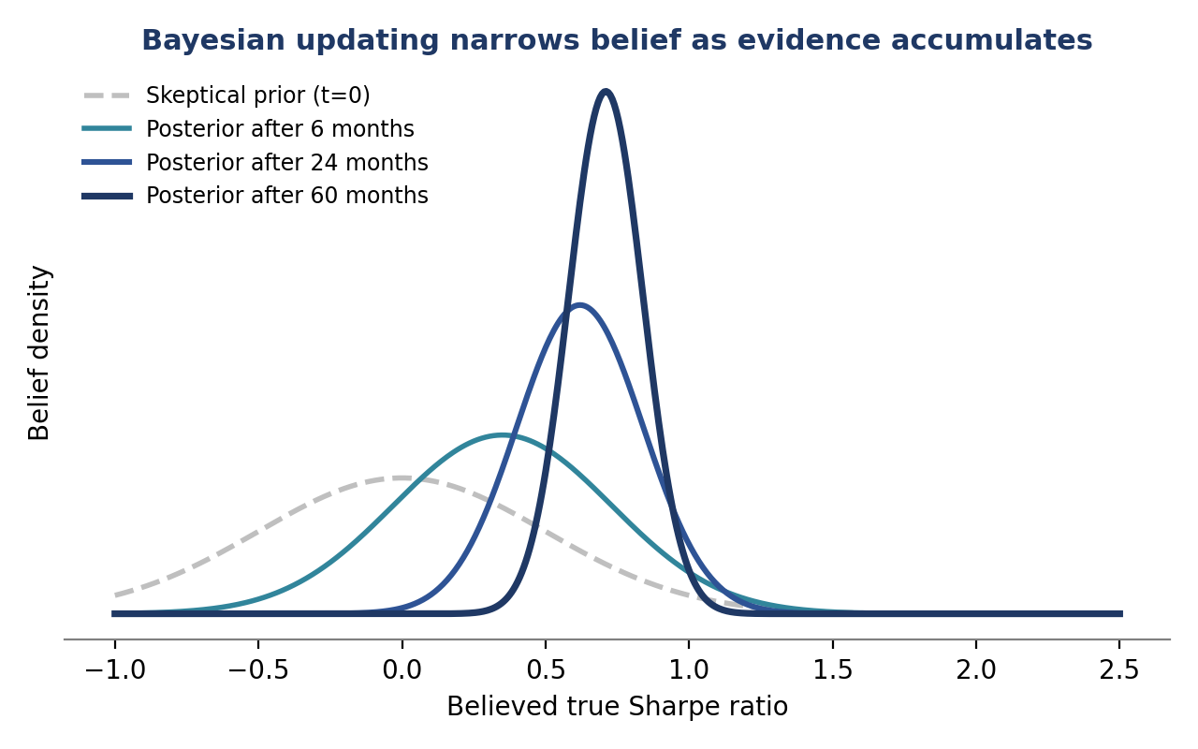
Figure 7.1 — Belief about a signal’s true Sharpe ratio starts from a wide, skeptical prior centred near zero and narrows and shifts toward the data as more out-of-sample months accumulate; after 60 months the posterior is both higher and far more confident than after 6.
Hierarchical models
A hierarchical (multi-level) model extends this idea across many related units at once — for example, many similar signals across different sectors, or the same strategy across many international markets. Rather than estimating each unit’s effect in complete isolation, a hierarchical model lets units ‘borrow strength’ from each other: a sector with little data gets pulled (shrunk) toward the average behaviour of all sectors, while a sector with abundant, consistent data is allowed to deviate further from that average. This partial pooling is a principled, data-driven alternative to the ad hoc choice between ‘treat every sector completely separately’ and ‘assume every sector is identical.’
- Shrinkage: Estimates for data-poor groups are pulled toward the overall (or nearest-neighbour group) average, reducing the risk of over-reacting to a single group’s noisy small sample.
- Partial pooling: The degree of shrinkage is itself estimated from the data — groups are pooled more when they appear genuinely similar, and less when the data suggest real heterogeneity between them.

7.3 State-Space Models, Hidden Regimes & Structural Breaks
Many market phenomena are best described by an unobserved (‘hidden’ or ‘latent’) state that is not directly measurable but that governs the statistical behaviour of what is measurable. A state-space model formalises this: a state equation describes how the hidden state evolves over time, and an observation equation links that hidden state to the data actually observed, such as returns or prices. Two closely related applications recur constantly in quant research.
- Hidden regimes: A market may alternate between a small number of discrete, unobserved regimes — for example, calm/low-volatility and stressed/high-volatility — each with different statistical properties (volatility, correlation, mean return). A hidden Markov model estimates both the properties of each regime and the probability of being in each regime at every point in time, purely from the observed data.
- Structural breaks: A single, identifiable point in time at which the data-generating process changes permanently — a regulatory change, a change in market microstructure, a central bank regime shift — rather than a recurring alternation between a fixed set of regimes.
- Filtering vs. smoothing: Filtering estimates the hidden state using only data up to the current time (what a live trading system can actually use); smoothing uses the full dataset, including future observations, to produce the best possible historical reconstruction (useful for research, not for live decisions, since it uses information not yet available at each point in time).
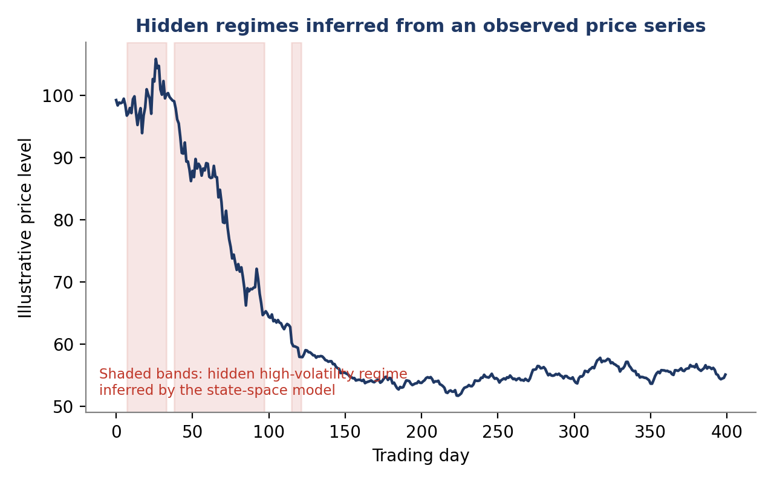
Figure 7.2 — A state-space model can infer periods of hidden high-volatility regime (shaded) purely from an observed price series, without those regimes being labelled in the data; note that regime probability, not certainty, is what such a model actually outputs.
The practical link to trading is direct: a dynamic allocation method that reduces size or shifts factor exposure when the inferred probability of a stressed regime rises is using exactly this machinery, which is why regime models built at this level feed directly into the dynamic allocation methods used in Level 5 advanced systematic trading.

7.4 Extreme-Value Methods, Copulas & Dependence Modelling
Standard risk models built on the normal (Gaussian) distribution and simple linear correlation systematically underestimate two related things that matter most during a crisis: how extreme a single asset’s worst days can be, and how much more than usual different assets move together during those worst days. Extreme-value theory and copula methods exist specifically to address each of these gaps.
- Extreme-value theory (EVT): Rather than fitting a single distribution to all the data, EVT focuses specifically on the tail — the largest losses — and fits a distribution justified by theory to describe exactly how extreme the extremes can get, typically producing fatter, more realistic tail-risk estimates than a normal-distribution assumption.
- Copulas: A copula separates the description of each asset’s individual (marginal) behaviour from the description of how assets are joined together (their dependence structure). This makes it possible to combine well-understood marginal distributions for each asset with a dependence structure that specifically captures tail dependence — the tendency for extreme moves to cluster together — something a single correlation number cannot represent.
- Tail dependence: The probability that one asset experiences an extreme move given that another asset already has. Two portfolios can have identical average correlation yet very different tail dependence, with very different consequences for how much of a benefit diversification actually provides during a crash.
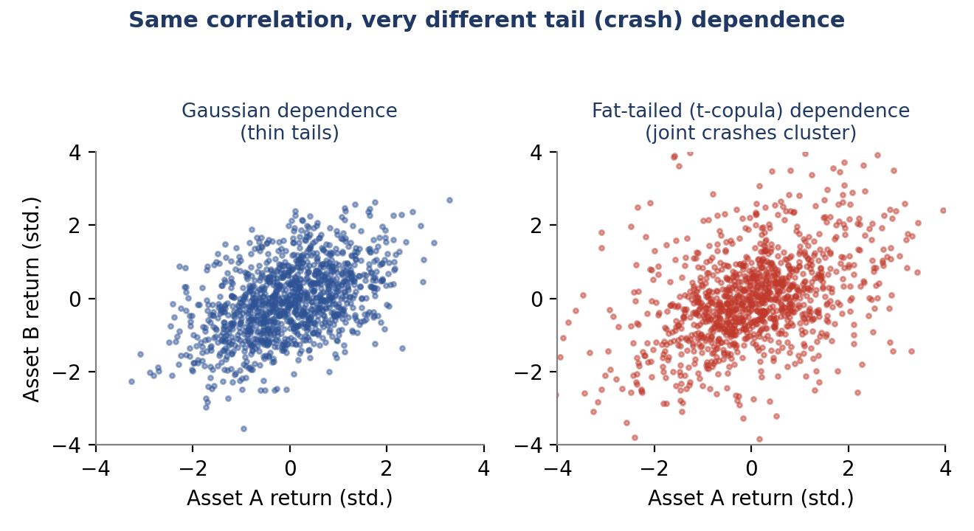
Figure 7.3 — Two asset pairs with the same overall correlation (≈0.5) can have very different tail behaviour: the Gaussian-dependence pair (left) rarely produces simultaneous extreme moves, while the fat-tailed, t-copula pair (right) produces visibly more joint excursions into the corners — simultaneous large moves in both assets.
⚠ Why this matters for portfolio construction
- A risk model that assumes Gaussian dependence will understate the likelihood of several positions losing money at the same time, precisely during the market stress periods when that correlation matters most.
- Portfolios built on diversification assumptions from average-period correlation alone can behave far more like a single concentrated position exactly when a cushion is needed.

7.5 Causal Inference, Synthetic Controls, Instrumental Variables & Treatment Effects
A correlation between a feature and future returns is, on its own, silent about causation: the feature might genuinely drive returns, returns might drive the feature, or some third, unobserved factor might drive both (confounding). Causal inference is the set of tools for answering the sharper question — does changing this feature change returns, holding everything else fixed — using observational data where a controlled, randomised experiment is not available.
- Identification strategy: The specific argument, grounded in how the data were generated, for why an estimated relationship should be interpreted causally rather than merely correlationally. Without an explicit identification strategy, causal language is not justified regardless of how sophisticated the statistical method used.
- Instrumental variables (IV): A variable that affects the outcome only through its effect on the feature of interest (and not through any other channel) can be used to isolate the causal effect of that feature, even when the feature itself is confounded with the outcome. Finding a credible instrument — one that genuinely satisfies this exclusion restriction — is usually the hardest part of an IV analysis.
- Synthetic controls: When a single unit (a market, a stock, a country) experiences an intervention or event and no single comparable untreated unit exists, a synthetic control constructs a weighted combination of untreated units that closely tracked the treated unit before the intervention, and uses the post-intervention gap between the actual and synthetic series as an estimate of the intervention’s causal effect.
- Treatment effects: The general term for the causal impact of an intervention (a ‘treatment’) on an outcome; distinguishing the average treatment effect (across all units) from the effect on units that were actually treated matters when the treatment was not applied at random.
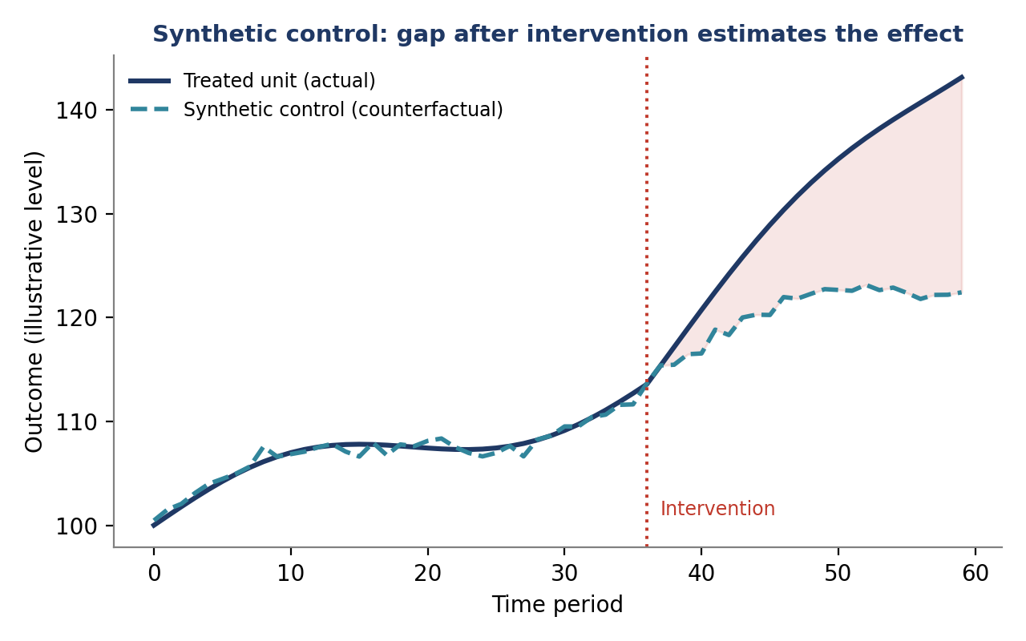
Figure 7.4 — A synthetic control is built to track the treated unit closely before an intervention; the widening gap between the treated unit and its synthetic counterfactual after the intervention is the estimated causal effect, under the assumption that the synthetic control continues to represent what would have happened without the intervention.
Worked example: a plausible identification strategy
- Correlational finding: stocks that are added to a major index tend to outperform in the weeks around the announcement.
- Confounding concern: firms are not added to an index at random — index committees tend to add firms that have already grown, so the same growth that caused outperformance could also have caused the index addition, making the addition itself look causal when it is not.
- Identification strategy: index additions driven by mechanical rule changes (e.g. a market-cap threshold crossed by a small margin, or a reconstitution formula) that do not depend on a committee’s discretionary judgement provide a cleaner natural experiment, since firms just above and just below the mechanical threshold are otherwise similar — a regression discontinuity design around that threshold is a credible identification strategy for isolating the causal price effect of index inclusion itself.

7.6 Worked Exercise — Model Answer
Exercise: Use a Bayesian approach to update your belief about a signal’s true Sharpe ratio as new out-of-sample months of data arrive, starting from a skeptical prior.
Model answer structure
- Specify a skeptical prior. A reasonable starting point centres the prior on a true Sharpe ratio near zero, with a standard deviation wide enough to comfortably include both ‘the signal has no edge’ and ‘the signal has a strong edge’ — for instance, a prior mean of 0.0 and a prior standard deviation of roughly 0.5, reflecting genuine pre-data uncertainty rather than false precision.
- Update after each new batch of out-of-sample months using Bayes’ theorem, combining the prior with the likelihood of the newly observed returns; in the simplest Gaussian case this update has a closed form and can be recomputed by hand or in a few lines of code each month.
- Report a credible interval, not just a point estimate — for example, ‘after 24 months, there is an estimated 90% probability the true Sharpe ratio lies between 0.25 and 1.0’ — which communicates the remaining uncertainty explicitly rather than implying false confidence in a single number.
- Track how the posterior moves as data accumulate (Figure 7.1 shows a stylised version of exactly this): a posterior that keeps drifting materially with each new month suggests the belief has not yet stabilised and more data (or more skepticism) is warranted before sizing the strategy aggressively.
- Compare against the frequentist alternative: a classical significance test on the same data would return a single p-value and a binary reject/fail-to-reject verdict at a chosen threshold, discarding the graded, cumulative picture of belief that the Bayesian approach preserves month over month.

7.7 Common Mistakes — Deeper Look
Mistake: Applying causal-inference terminology to a purely correlational finding without a credible identification strategy
Words like ‘causes’, ‘drives’, or ‘effect’ carry a specific, technical claim: that intervening on one variable would change another, holding everything else fixed. Using this language to describe a correlation observed in historical data — without an explicit argument for why confounding, reverse causation, or selection has been ruled out — overstates what has actually been shown and can lead to a strategy being sized as if it exploits a durable, structural relationship when it may only be exploiting a coincidence or a two-way relationship that could reverse. The discipline is not to avoid the causal question, but to be explicit about the identification strategy being relied upon, and to be equally explicit when no such strategy is available — in which case the finding should be described as correlational, plainly.
Mistake: Using a complex hierarchical or state-space model without checking whether a simpler model already explains the data adequately
Sophisticated models carry real costs beyond the obvious implementation effort: more parameters to estimate means more opportunity for the model itself to overfit (echoing §6.6’s researcher-degrees-of-freedom concern, now embedded inside model architecture rather than research process), results that are harder for a second researcher to audit or reproduce, and a false sense of rigour that can substitute for genuine economic reasoning about why the added complexity is needed. A disciplined workflow fits the simplest reasonable model first, checks its residuals and out-of-sample performance, and adds complexity such as regime-switching or hierarchical structure only when there is clear, specific evidence that the simpler model is missing something the added structure would capture.
⚠ A useful discipline: complexity must earn its place
- Before adding a hidden-regime layer, hierarchical structure, or a copula-based dependence model, state in advance what specific empirical failure of the simpler model justifies the added complexity.
- If the more complex model’s out-of-sample performance is not meaningfully better than the simpler model’s, the simpler model should generally be preferred — it is easier to reproduce, easier to explain, and less prone to hidden overfitting.

7.8 Advanced Extensions
- Full measure-theoretic probability: The formal mathematical foundation (sigma-algebras, measurable functions, martingale theory) underlying rigorous treatments of continuous-time finance and derivatives pricing; genuinely necessary only for reading or contributing to advanced academic literature in that specific area, rather than for the applied Bayesian, state-space and causal methods covered above.

7.9 Professional Applications
- Signal confidence-weighting: Sizing a strategy’s allocation according to the posterior confidence in its edge (per §7.2 and the worked exercise in §7.6), rather than treating every signal that clears a fixed significance threshold identically.
- Regime-aware research: Building research and risk processes that explicitly condition on the inferred market regime (§7.3), so that a strategy’s expected behaviour and sizing can adapt to hidden shifts in volatility or correlation rather than assuming a single, constant statistical environment.
- Academic-grade research publication: Producing internal (or external) research write-ups that meet the standard of an academic causal-inference or Bayesian-statistics paper — explicit identification strategies, stated priors, reported uncertainty — rather than a single backtest chart and a headline Sharpe ratio.

